Jamar Andrade

Professor Burke Fort

Fall Semester 2022 W/F

10/21/2022

**COP 4610 - Programming Assignment**

**CPU Scheduler**

**Table of Contents:**

FCFS: Pages 2 – 6

SJF: Pages 7 – 10

MLFQ: Pages 11 – 14

**Introduction:**

CPU scheduling is a process that allows one process to use the CPU while another process is delayed due to the unavailability of resources (I/O), thus making use of the CPU. The CPU scheduling process makes the system more efficient, faster, and fairer. The operating system must select one process in the line ready for launch, the selection process is done by a temporary CPU scheduler. The scheduler selects between memory process ready to launch and assigns the CPU to one of them.

The main function of CPU scheduling is to ensure that whatever the CPU remains idle, the OS has at least selected one of the processes available in the ready-to-use line. The objectives of process scheduling algorithms are the utilization of the CPU at maximum level (keep CPU as busy as possible), maximum throughput, minimum turnaround time, minimum waiting time, and minimum response time. All CPU scheduling algorithms, for the most part, try to achieve these characteristics, some stronger than others but comes with a price.

There are two types of CPU scheduling, non-preemptive and preemptive. Non-preemptive scheduling of new processes is executed only current process has been completed. The process holds the resource of the CPU (CPU time) till its state changes to terminated or is pushed to the process waiting for the state. If a process is currently being executed by the CPU, it is not interrupted till it is completed. Once the process has completed its execution, the processor picks the next process from the ready queue. Preemptive scheduling takes into consideration the fact that some processes could have a higher priority and hence must be executed before the processes that have a lower priority. In priority scheduling, the CPU resource is allocated to process for only a limited period and then those resources are taken back and assigned to another process. If the process was yet to complete its execution, it is placed back in the ready state, where it will remain till it gets a chance to execute once again.

The goal of this project is to demonstrate a different kind of algorithm used by the CPU scheduler that was shown in class and understand how the algorithms operate by coding each one. The algorithms that we used for this project are First Come First Serve, Short Job First, and Multi-Level Feedback Queue, which all are non-preemptive.

**Come First Serve Flowchart:**

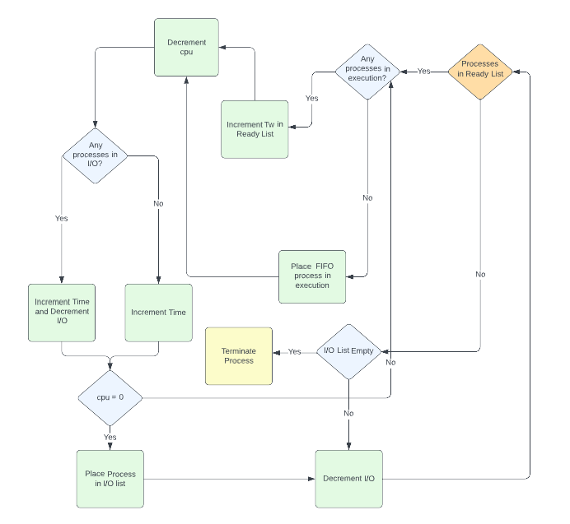

**FCFS Discussion:**

The first Come First Serve algorithm works as the name implies, whichever process is in the first index of the ready queue and no processes are currently running; then that process will run its CPU burst first. A FIFO approach if you will. While a process is under CPU execution no other process can preempt it(interrupt). Once the said process finishes its CPU burst, it will then go into I/O (waiting list) and the next process that was behind it will enter CPU execution.

**Pros:** Easy to implement and simple to understand.

**Cons:** Long wait time, lower device utilization, favors CPU over I/O, not complex, and not ideal for time-sharing systems.

**Sample GANNT Chart FCFS:**

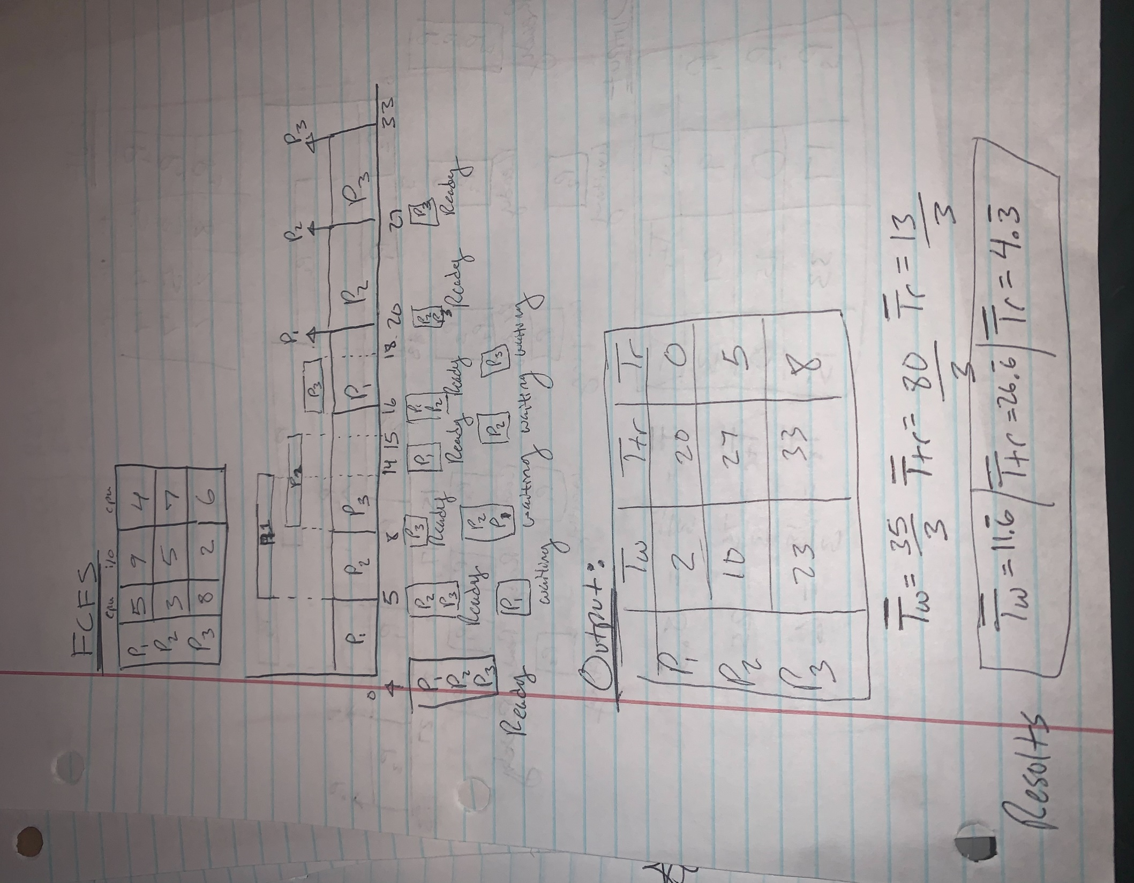

**FCFS Dynamic Execution at 100ms**

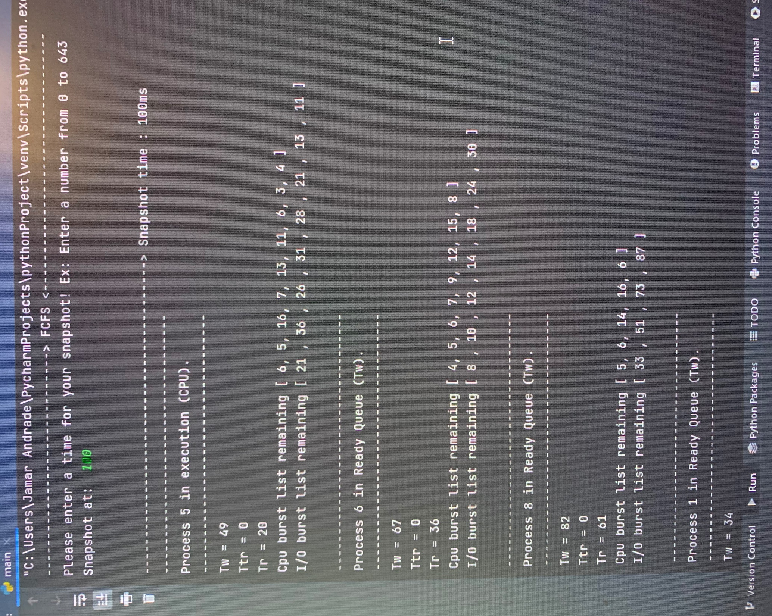

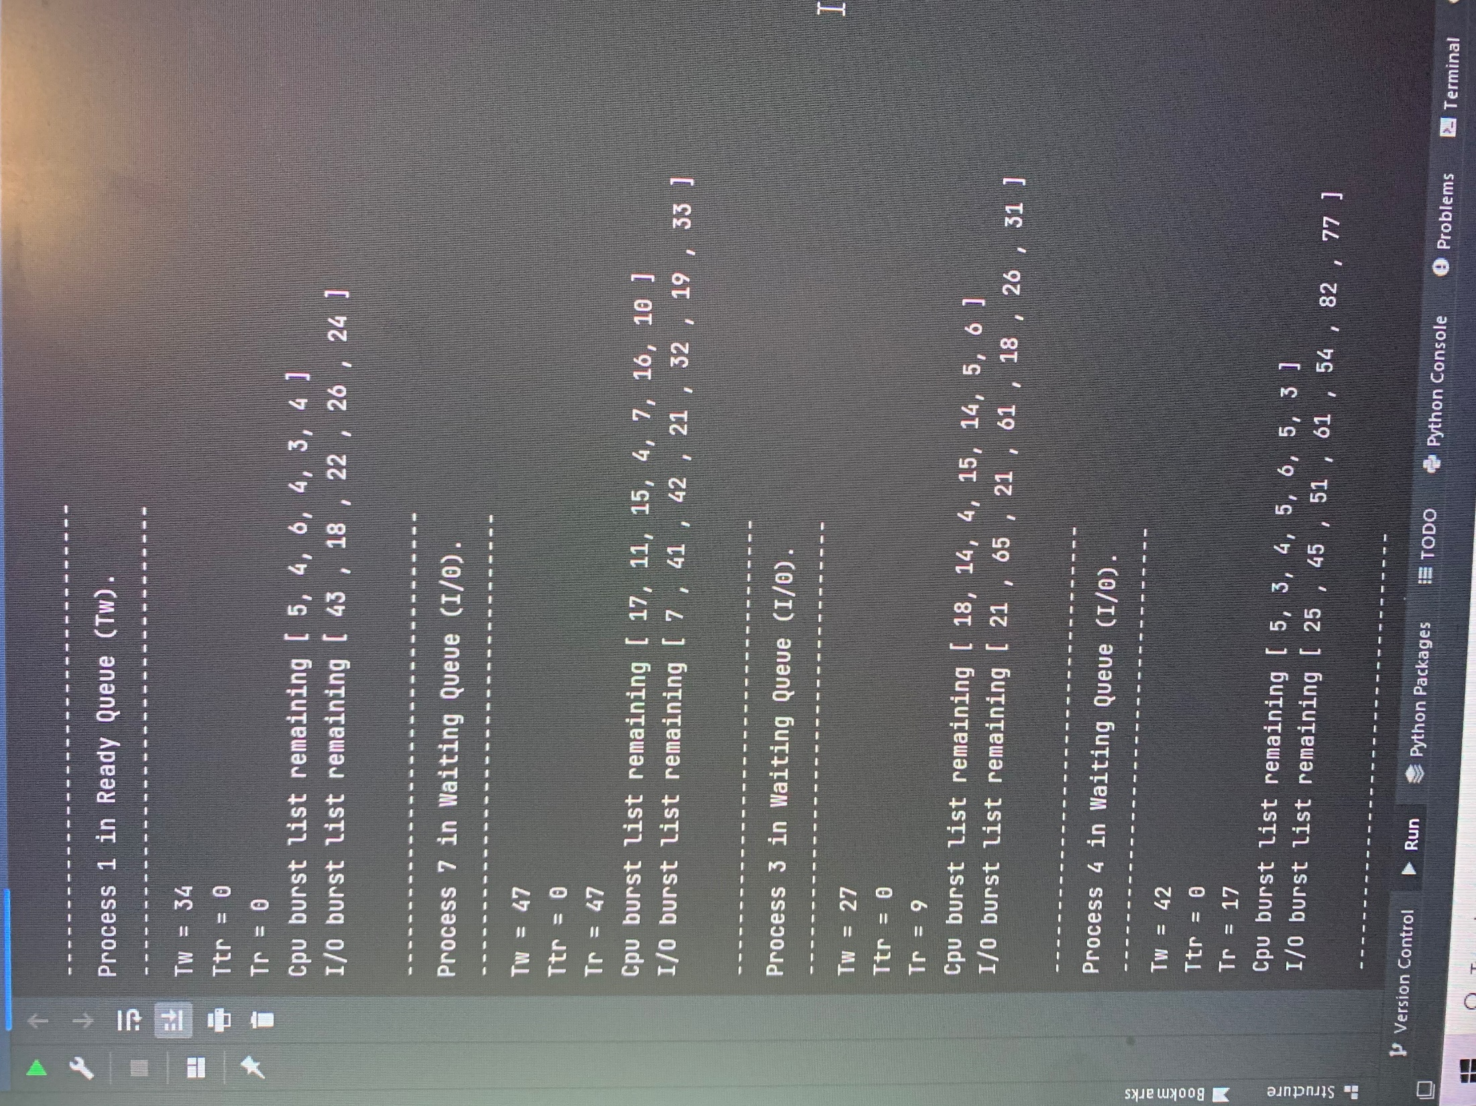

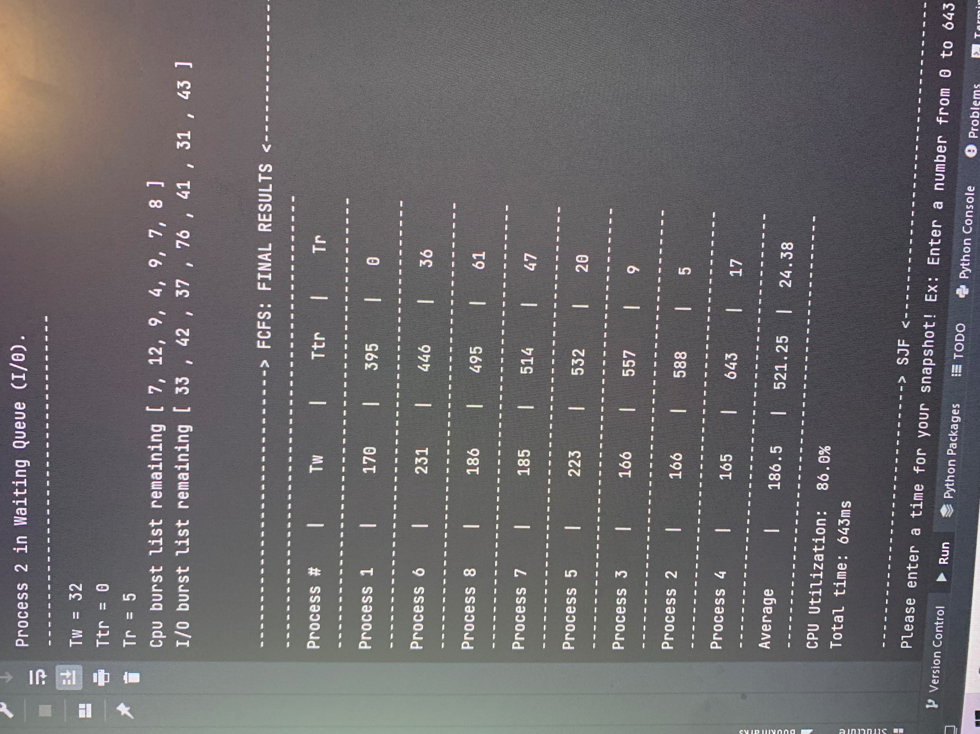

**SJF FLOWCHART:**

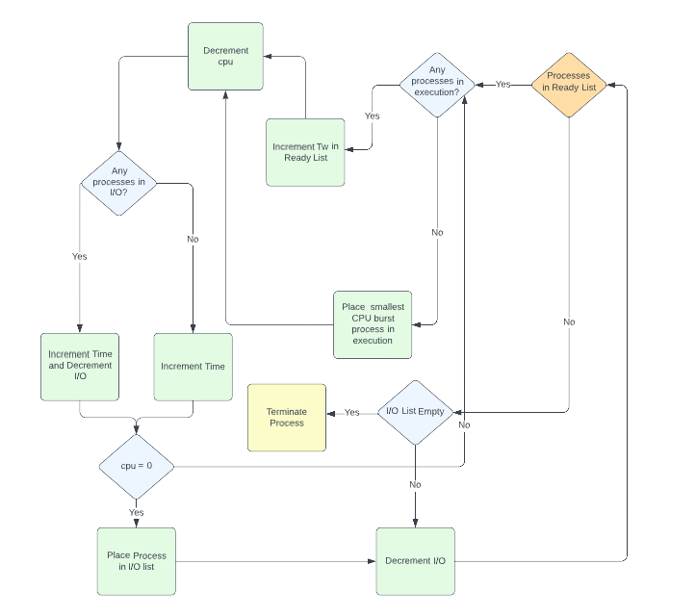

**SJF Discussion:**

Shortest job first is very similar to the First Come First Serve algorithm, what makes this algorithm special is that before a process enters CPU execution it will figure out which process has the shortest CPU burst and that process will gain the opportunity to run its execution. This makes JSF the most optimal algorithm out of the three. Same as FCFS it is also preemptive, so that process in execution will finish its CPU burst and then once finish go to I/O. Then the same process repeats until there are no more processes in ready or list and the program will terminate.

**Pros:** Reduces total wait time, which is the best criterion for the scheduler.

**Cons:** Hard to predict CPU bursts, batch system long scheduling, long turnaround(starvation), and doesn’t reduce turnaround time.

**Sample GANNT Chart SJF:**

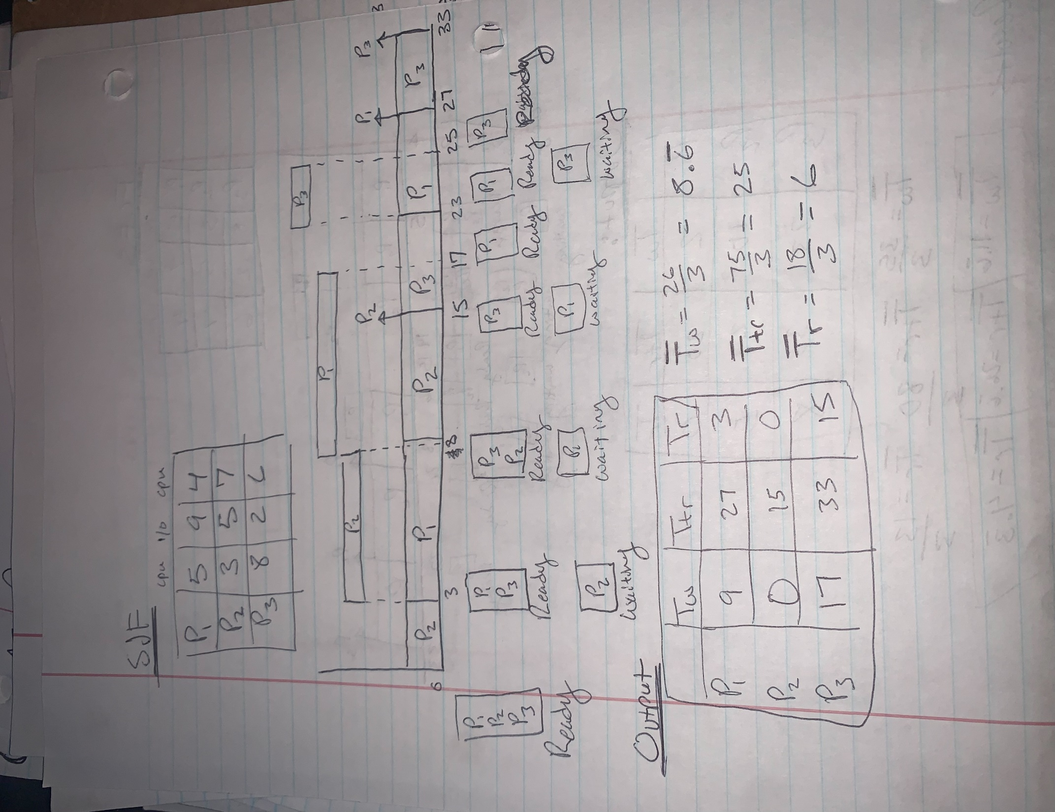

**SJF Dynamic Execution at 200ms**

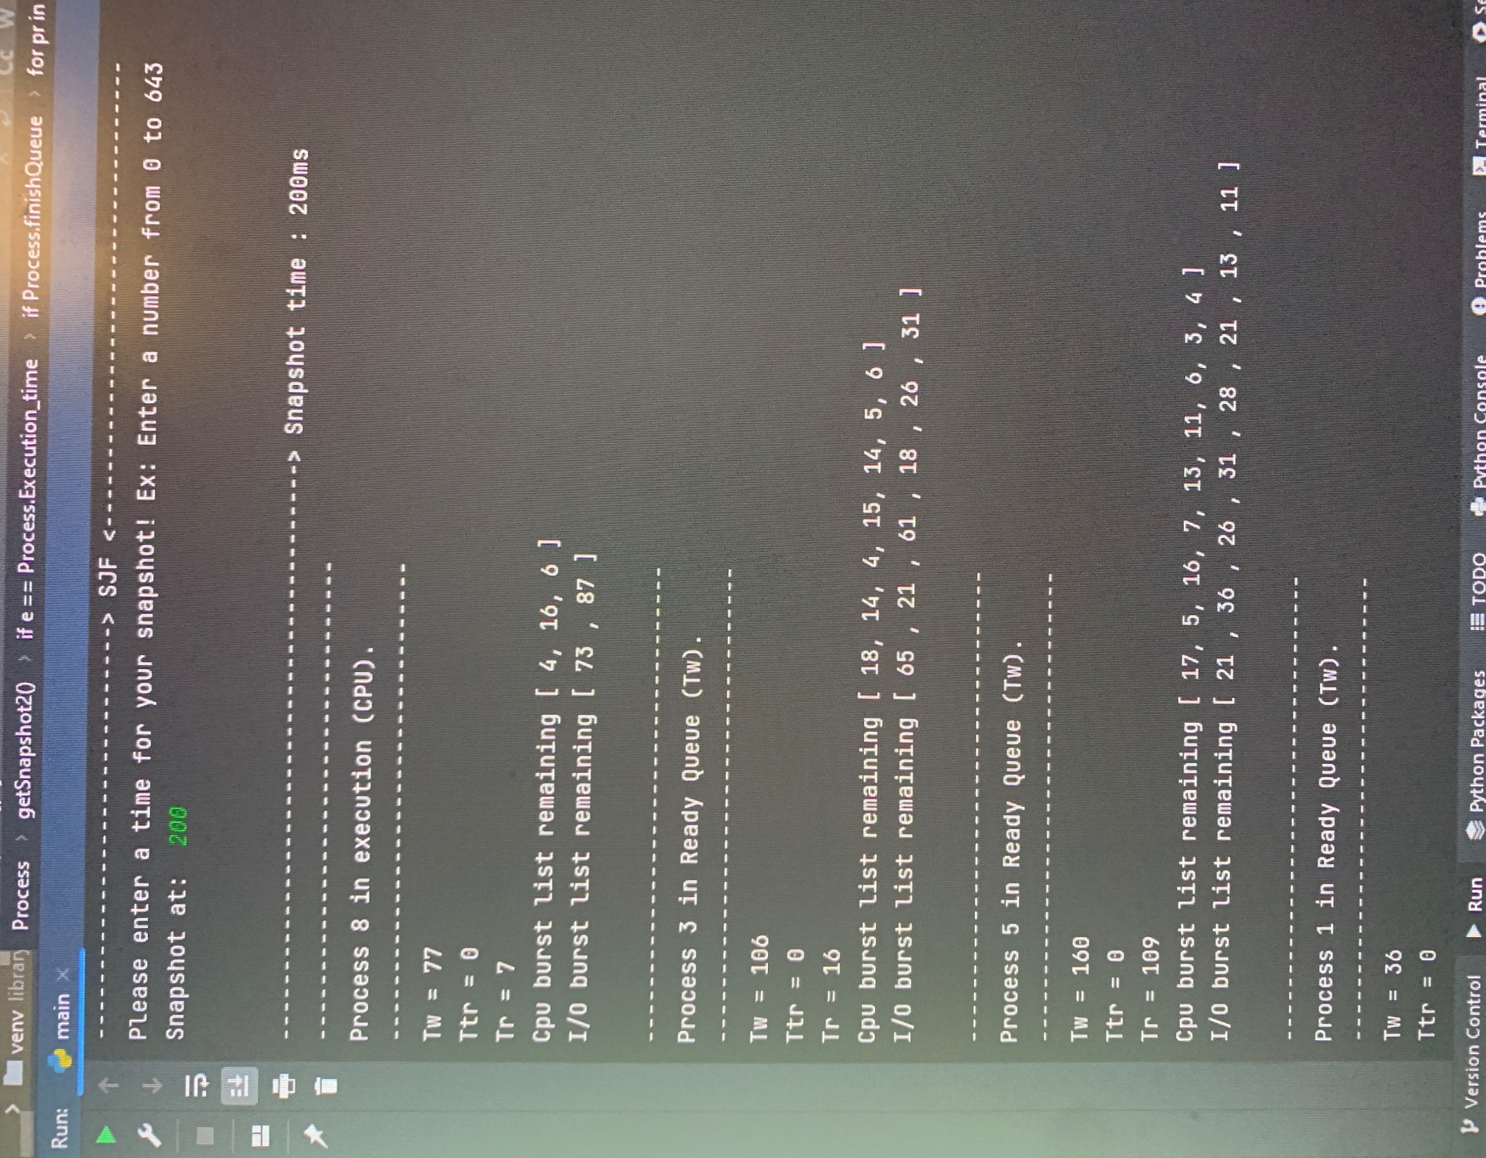

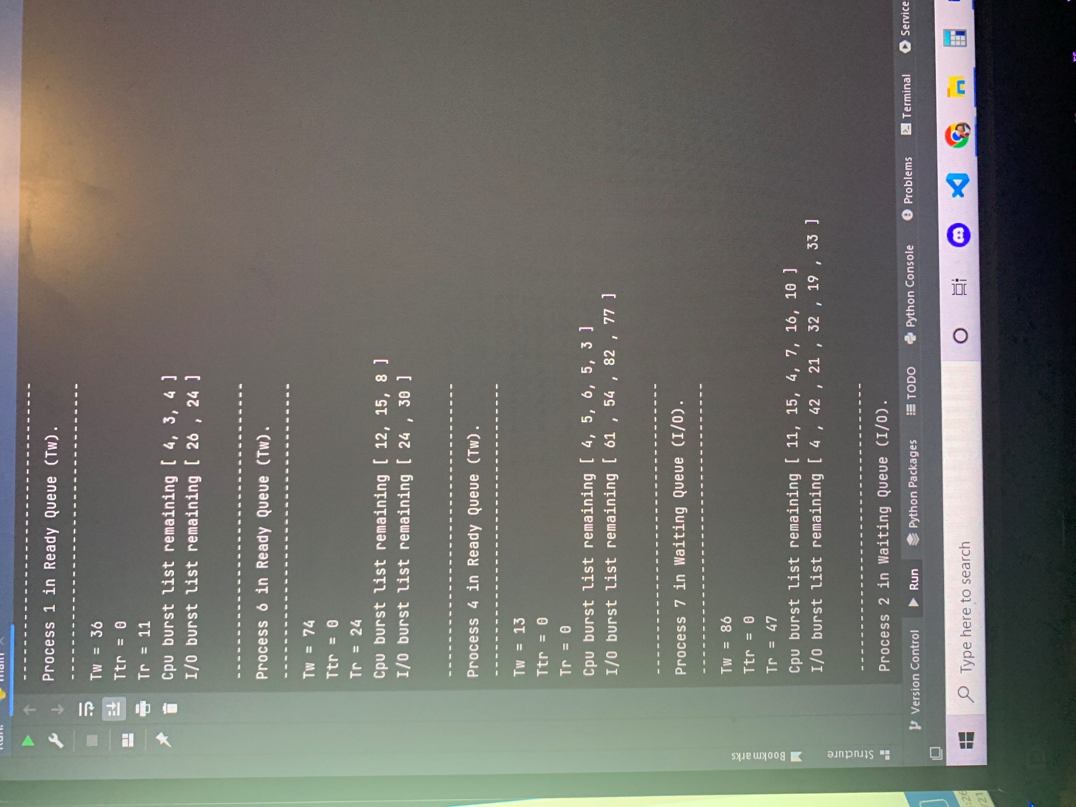

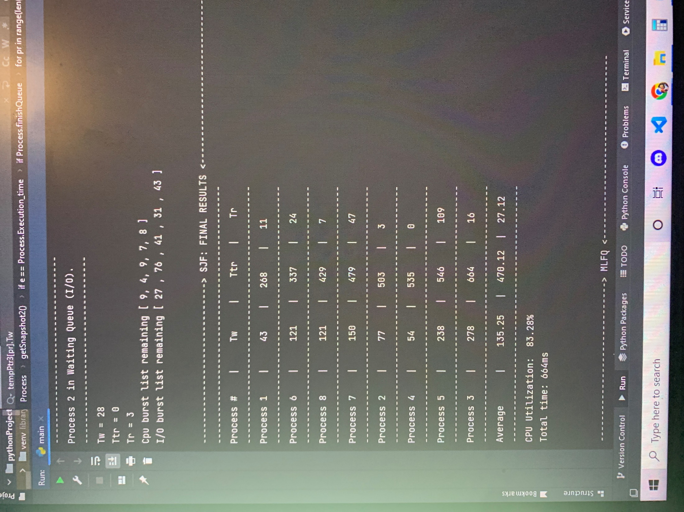

**MLFQ FLOWCHART:**

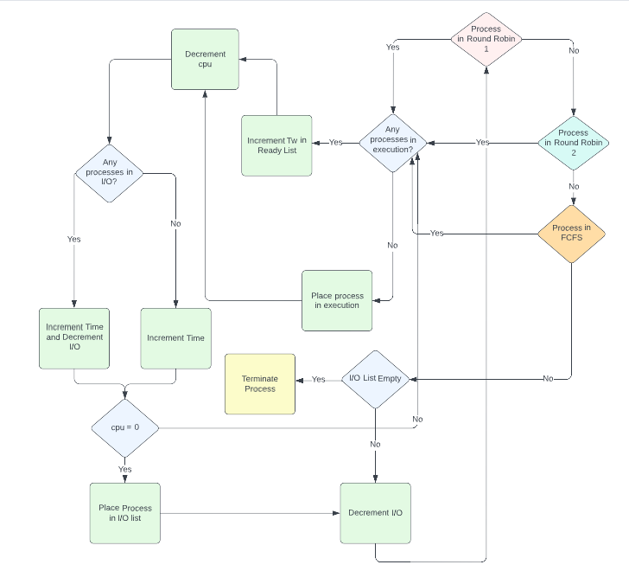

**MLFQ Discussion:**

Unlike FCFS and SJF, Multi-Level Feedback Queue has a priority ready list hierarchy that it follows when executing processes. Totaling three lists, two are called Round Robin and the last one is FCFS. What makes the Round Robin list special is that they are based on quantum time CPU burst execution, which means a process is only able to run for a certain time each Round Robin queue depending on how the programmer implements them. It’s ideal to separate processes with different CPU burst characteristics. All processes start in the first Round Robin queue and will be executed concerning the time quantum; if a process finishes its CPU burst it will be placed in I/O, else be demoted to the next queue (Round Robin #2). Then the process will repeat but if a process finishes I/O it will return to Round Robin #1 and after Round Robin finishes the current process in execution, Round Robin # 1 will have priority until that process finishes execution. Then Round Robin #2 processes will execute concerning the time quantum and place the process in either I/O if CPU burst is finished, else demoted to FCFS queue (final queue). The same rules apply to FCFS as Round Robin #2 is concerning Round Robin #1 but FCFS is the lowest priority so if a process returns to Round Robin #1, FCFS’s current process will finish execution but after Round Robin #1 will have priority and if the same process has more CPU than time quantum of Round Robin #1 it will go to Round #2, the same story until it reaches the I/O or FCFS.

**Pros:** Best turnaround time, prevents starvation, and allows processes to move between queues.

**Cons:** High CPU scheduling overhead, most complex algorithm.

**Sample GANNT Chart MLFQ:**

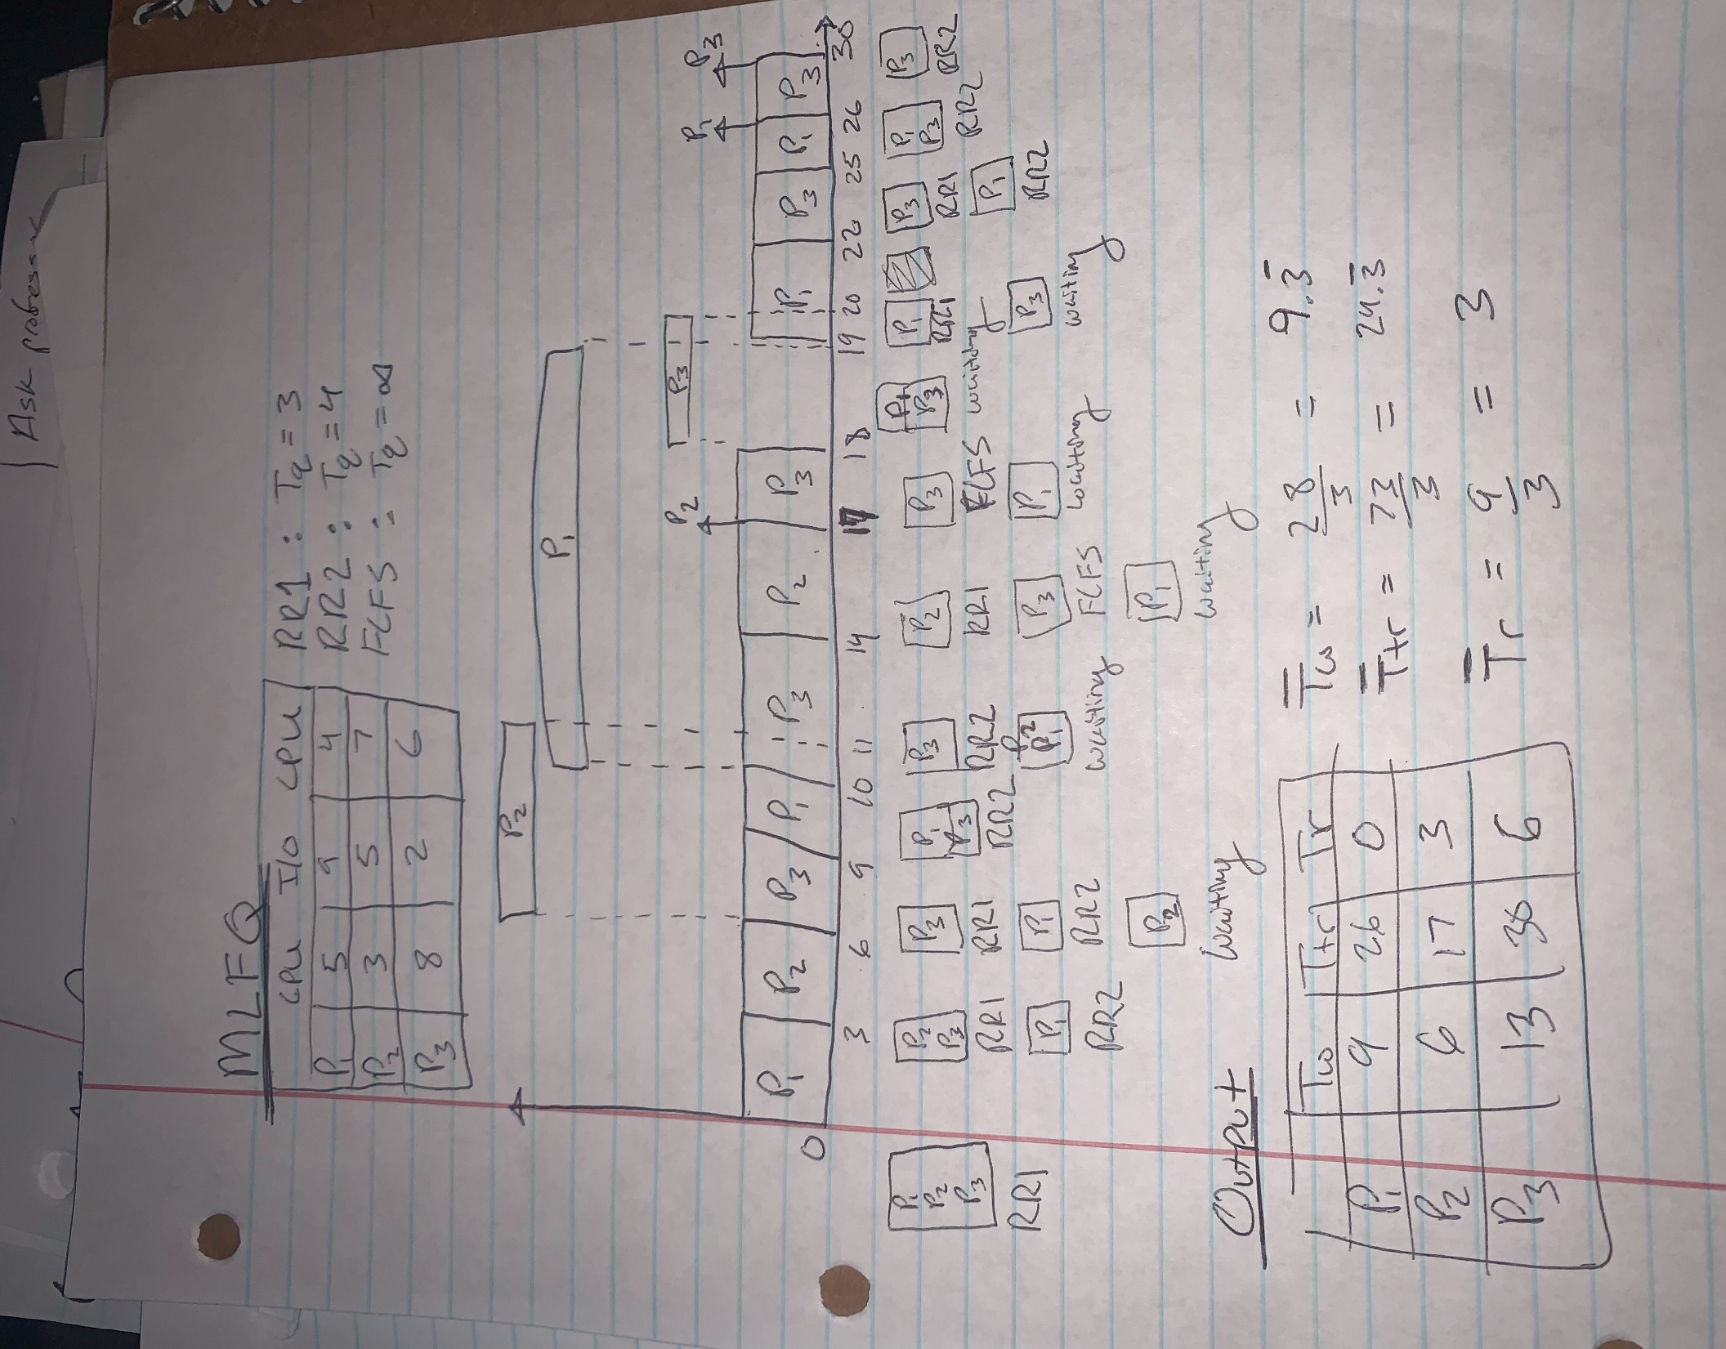

**MLFQ Dynamic Execution at 300ms**

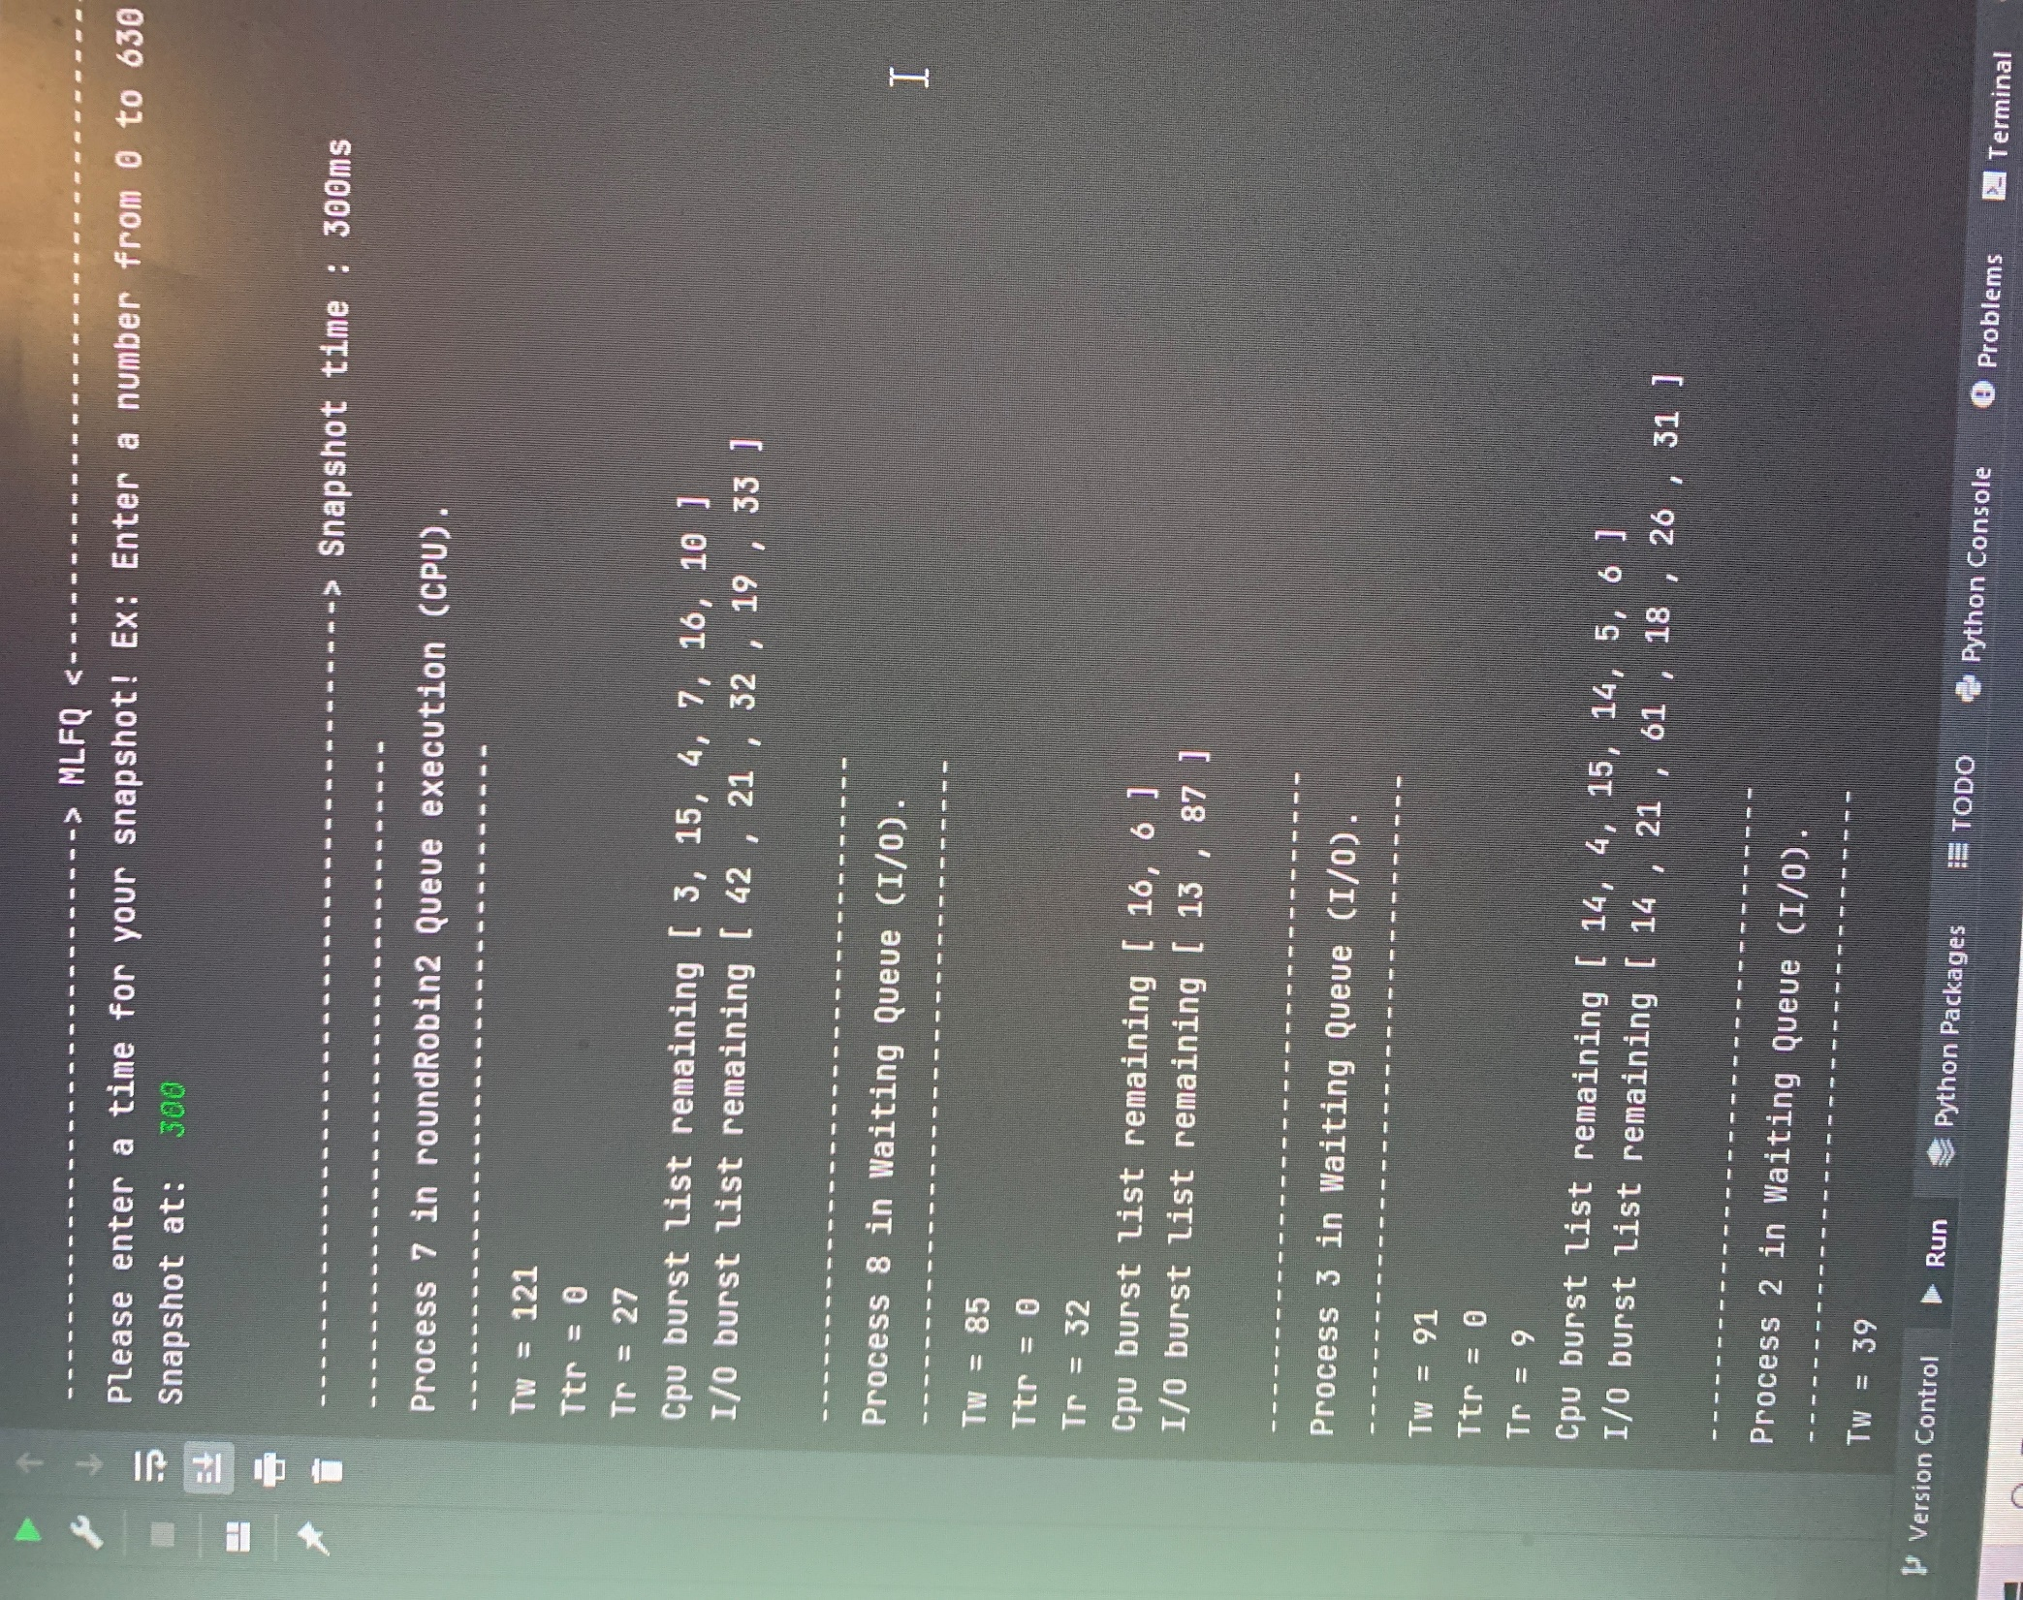

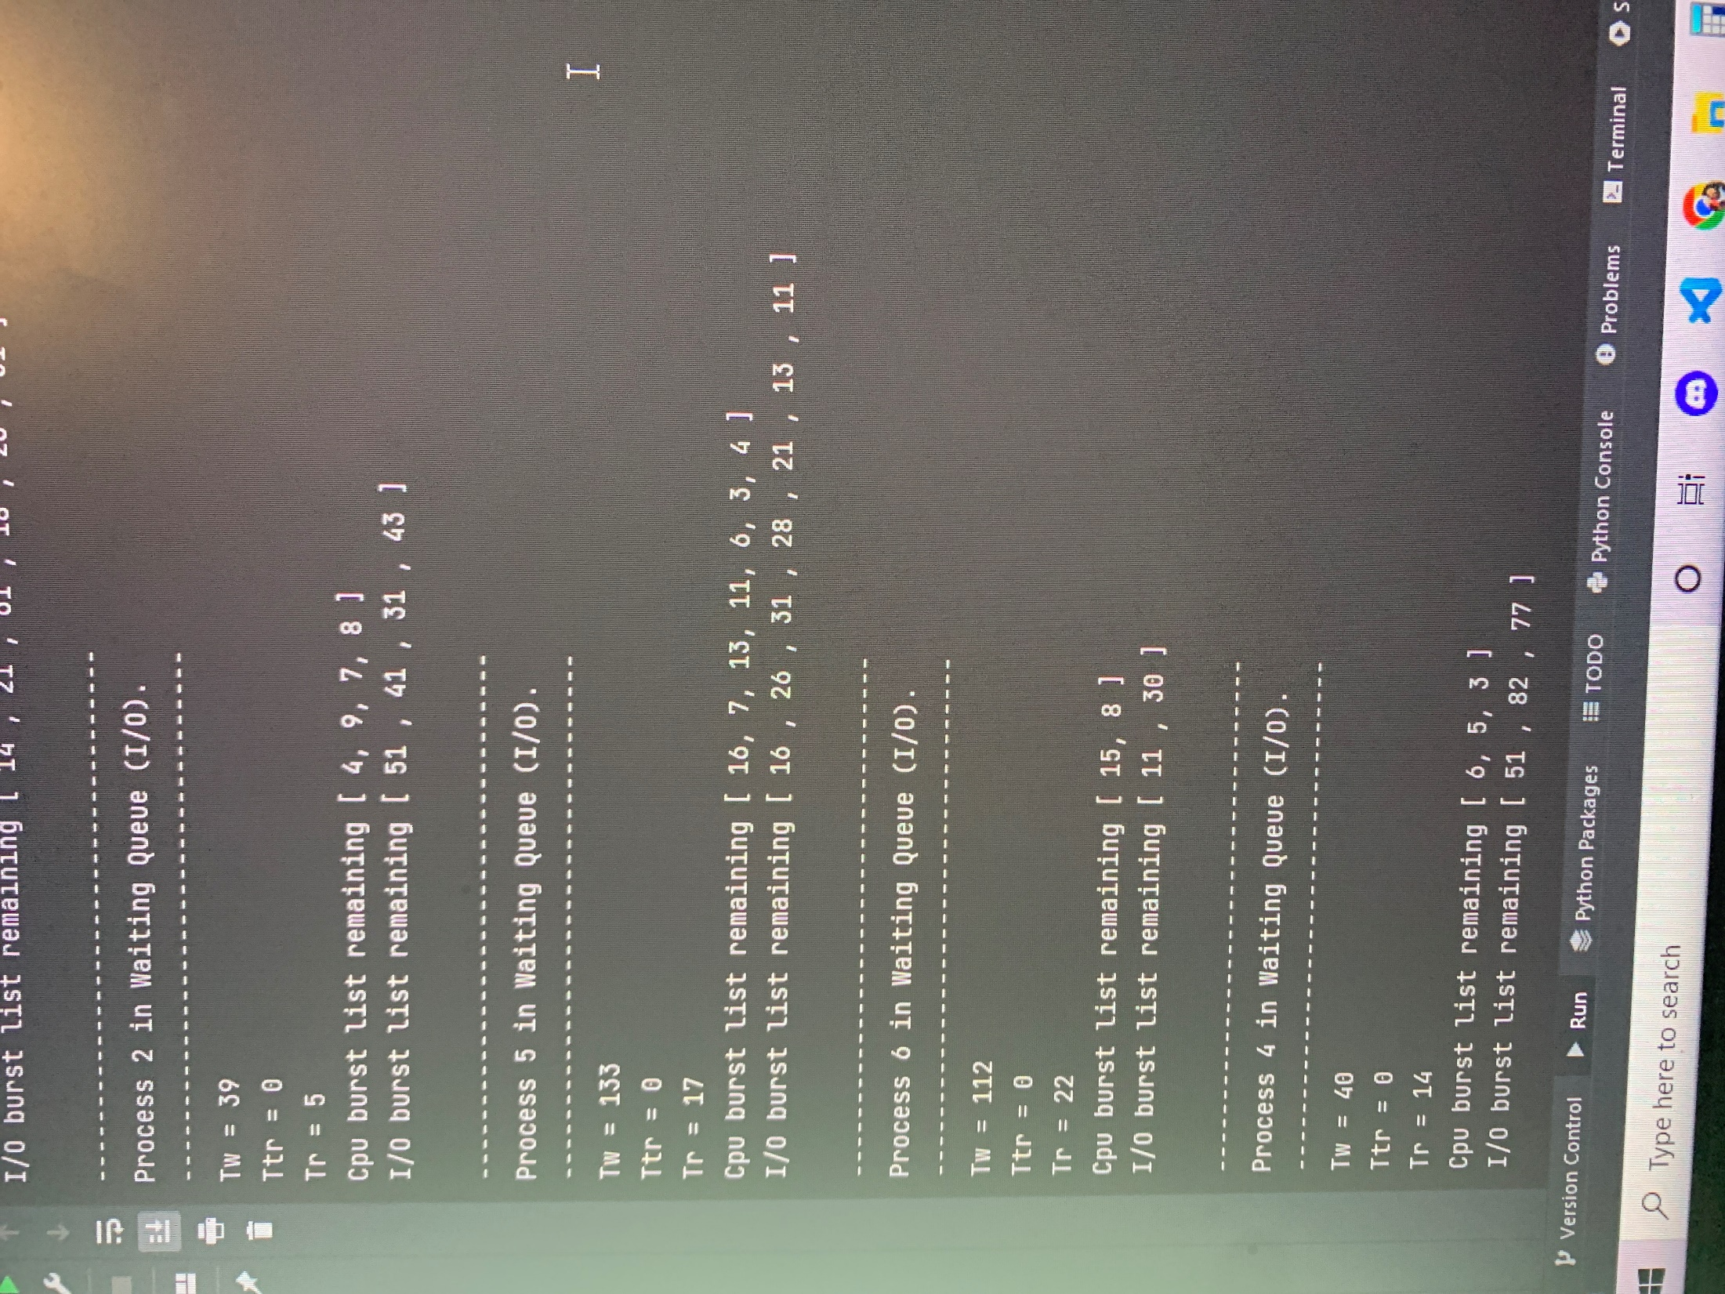

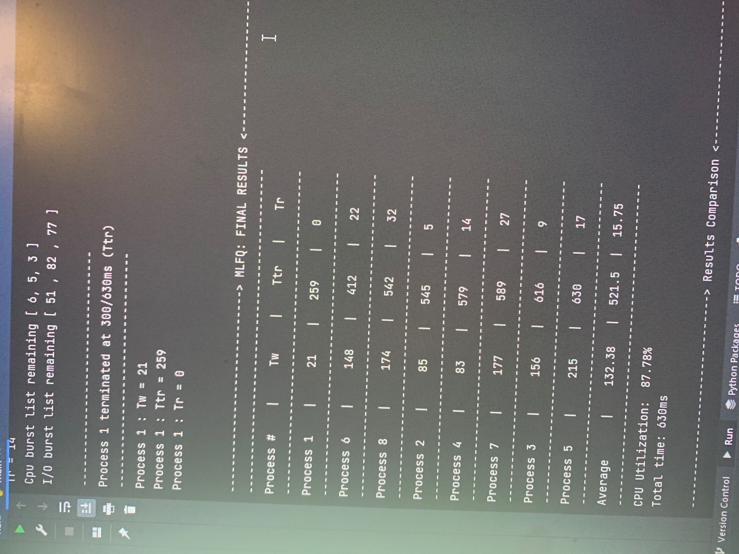

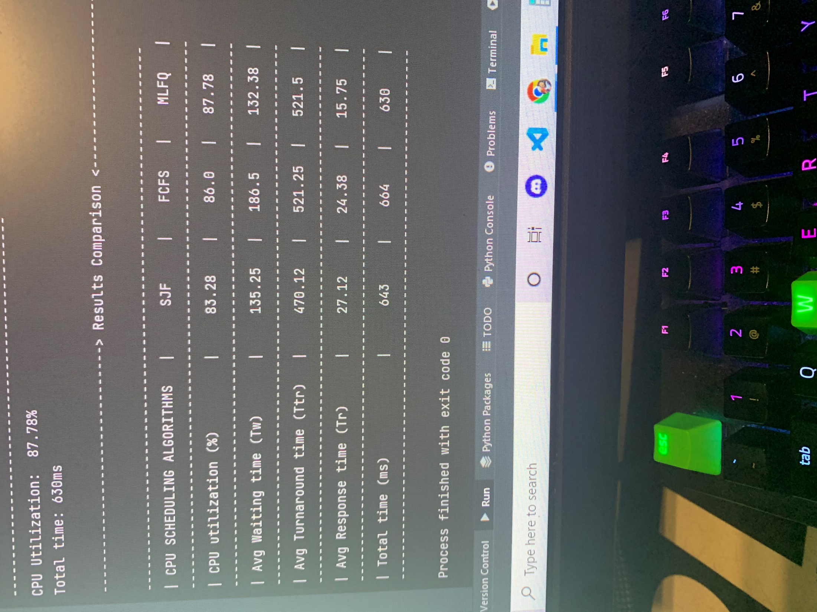

**Algorithms Comparison:**

1. SJF has the best turnaround time and gets the processes with the shortest CPU burst out of the way first.
2. MLFQ has the best CPU utilization, more processes are executed sooner.
3. MLFQ has the best response time, allowing processes to move in different queues.
4. MLFQ has the best lowest total time out of the three algorithms, executing processes sooner.
5. Overall MLFQ is the best choice when it comes to picking an algorithm from these three, FCFS would be ideal for shorter processes than the processes that were used in this project.

**Conclusion:**

Creating a more complex CPU scheduling algorithm could possibly lead to a more efficient output, either better CPU utilization, turnaround time, response time, wait time, or total execution time. With this project, we were able to understand the algorithms the CPU scheduler utilizes when processing processes. Each algorithm is not perfect, they have their advantages and disadvantages. Not to mention the difficulty of implementing these algorithms by hand gives us a reality check of how amazing CPU schedulers truly are.

**Cited Work:**

*CPU scheduling in operating systems*. GeeksforGeeks. (2022, July 5). Retrieved October 22, 2022, from https://www.geeksforgeeks.org/cpu-scheduling-in-operating-systems/#fcfs

Mathur, T. (2022, April 28). *CPU scheduling*. Scaler Topics. Retrieved October 22, 2022, from https://www.scaler.com/topics/operating-system/cpu-scheduling/